Ntier_APM_Security – Always On - Upgrade Rollback

Prior to Upgrade:
- Just before the upgrade process, make sure the Primary and Secondary are synchronized.
- Have Commvault team do a full backup of Ntier_APM_Security
- Verify with Commvault if tlog backups are working
Upgrade Steps:
- On Primary : Change the AG failover to “Manual” for both Nodes.
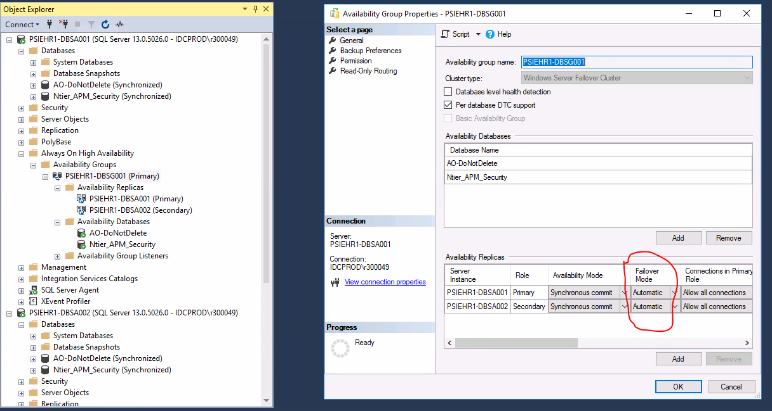

- On Secondary: Remove database Ntier_APM_Security from the AG
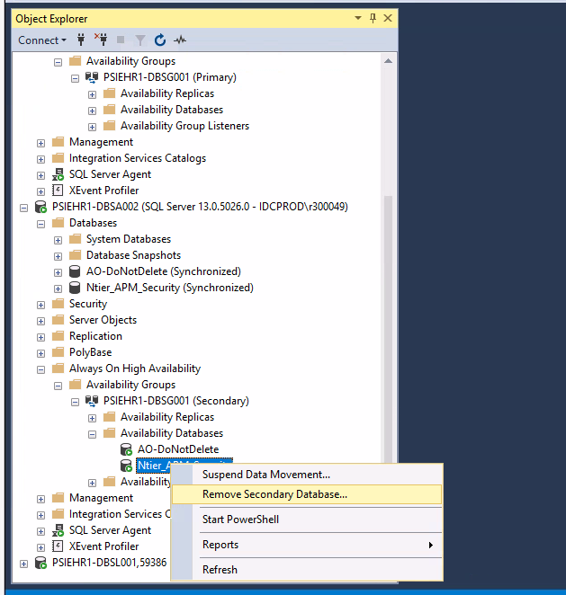
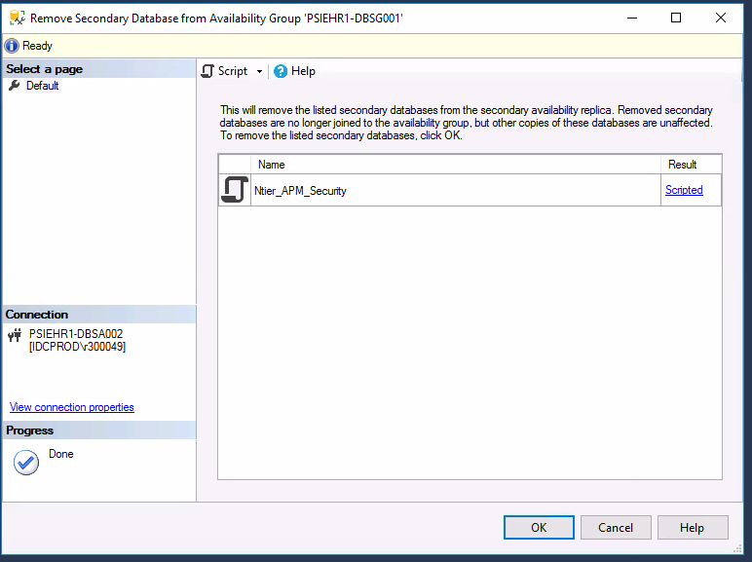
- Perform the upgrade.
- DBA Team to monitor tlog backups with Commvault team so the log file does not fill up the drive! VERY IMPORTANT!

If upgrade is successful:
- On Secondary: Drop the Ntier_APM_Security which is in restoring mode
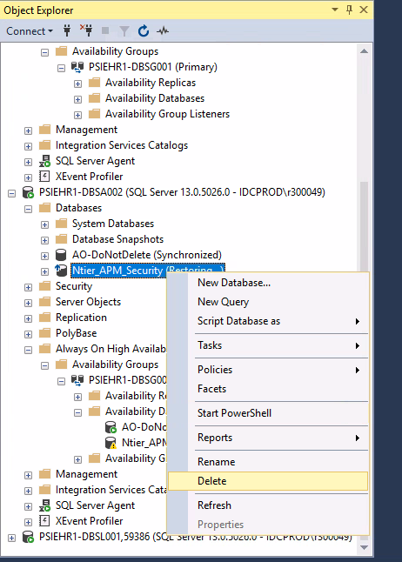
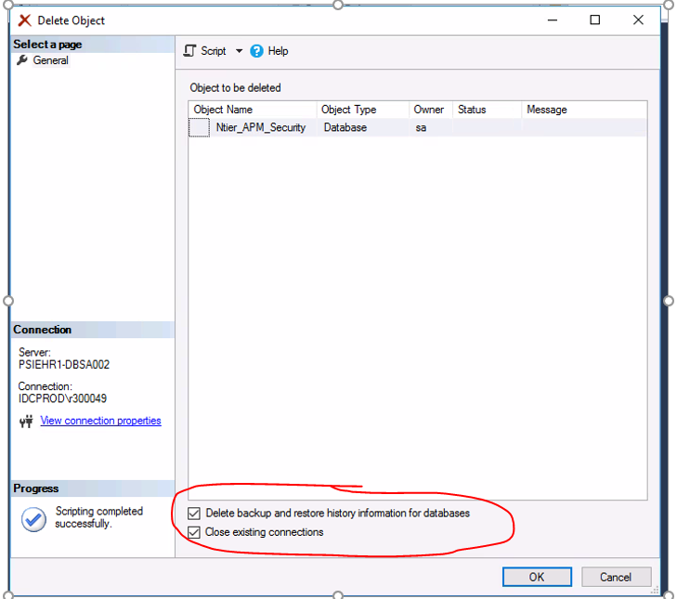
After deleting the database in secondary, you could still see the db with a warning in the AG, that is normal.
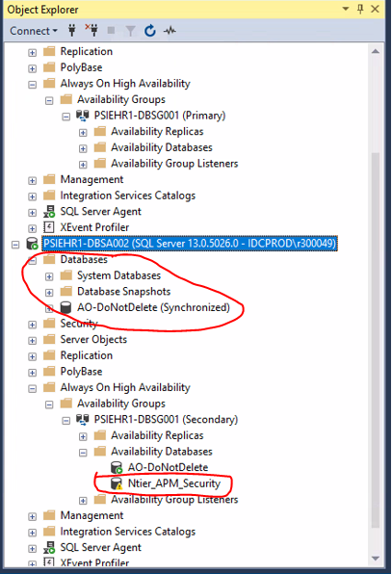

- On Primary: Run the tsql below. This will start the seeding of the Ntier_APM_Security on the Secondary
Use master
go
ALTER AVAILABILITY GROUP [PSIEHR1-DBSG001]
MODIFY REPLICA ON 'PSIEHR1-DBSA002'
WITH (SEEDING_MODE = AUTOMATIC)

Note the DB Ntier_APM_Security on the Secondary in restoring mode.
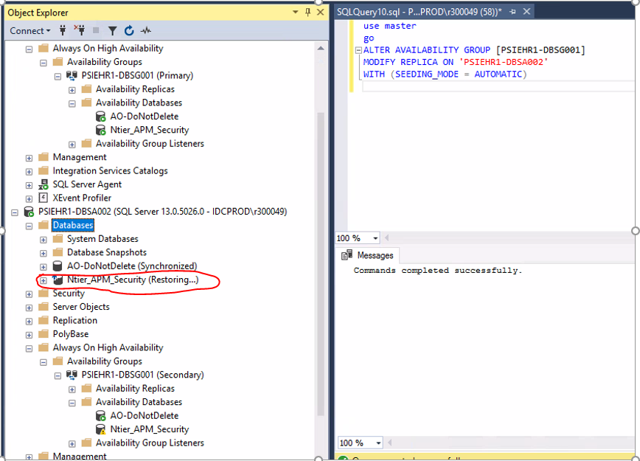
- On Secondary: Check if seeding is complete
SELECT top 1 start_time,
ag.name,
db.database_name,
current_state,
performed_seeding,
failure_state,
failure_state_desc
FROM sys.dm_hadr_automatic_seeding autos
JOIN sys.availability_databases_cluster db
ON autos.ag_db_id = db.group_database_id
JOIN sys.availability_groups ag
ON autos.ag_id = ag.group_id
order by start_time desc --See the Current_State as “Seeding”
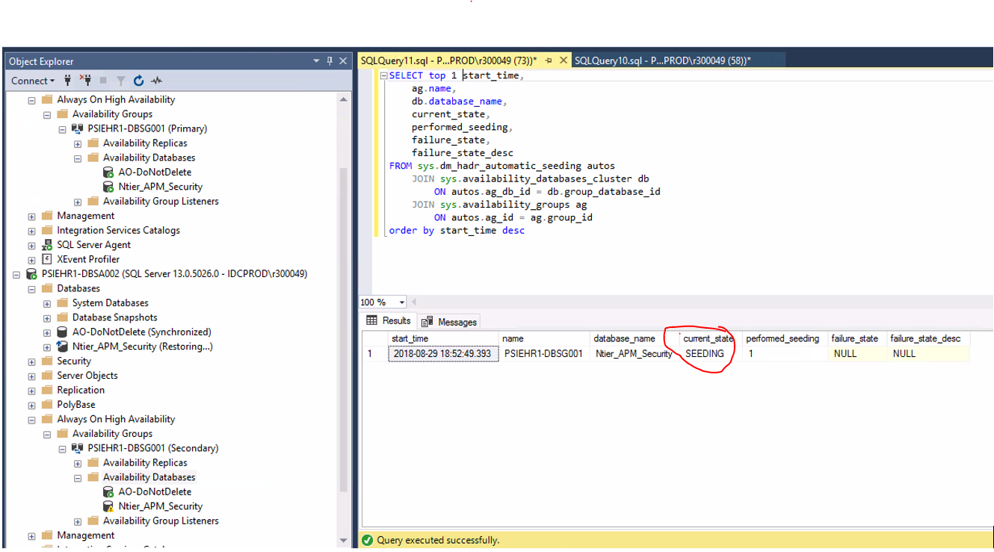
Seeding complete:
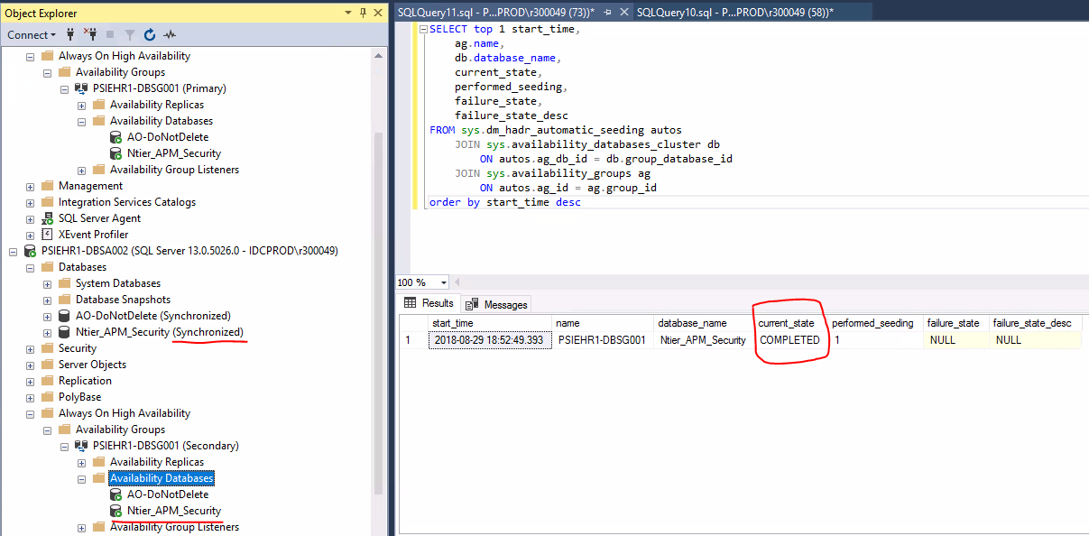
- On Primary: Change the AG failover to “Automatic”
All is Good! End of Upgrade process. No more action needed
Upgrade fails:
- On Primary: Remove database Ntier_APM_Security from the AG
- On Secondary: Restore with Recovery the DB Ntier_APM_Security
use master
go
restore database Ntier_APM_Security with recovery
go
Note the Database Ntier_APM_Security is restored, but not part of AG
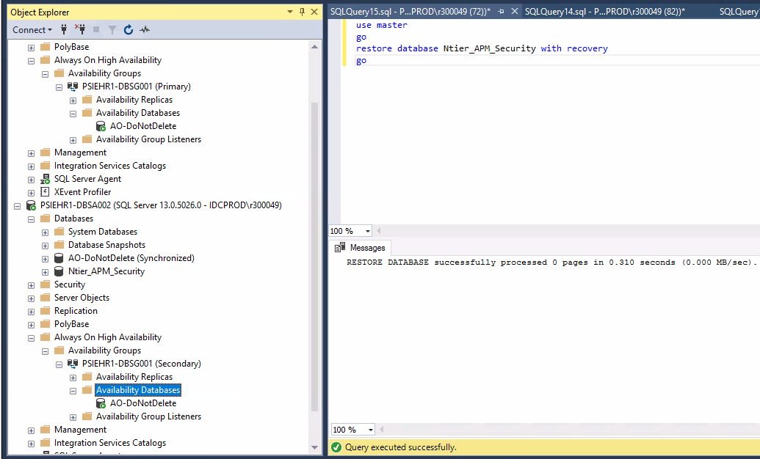

- On Primary: Do a manual Failover and Make the Secondary (that has the Ntier_APM_Security prior to upgrade changes) the new Primary
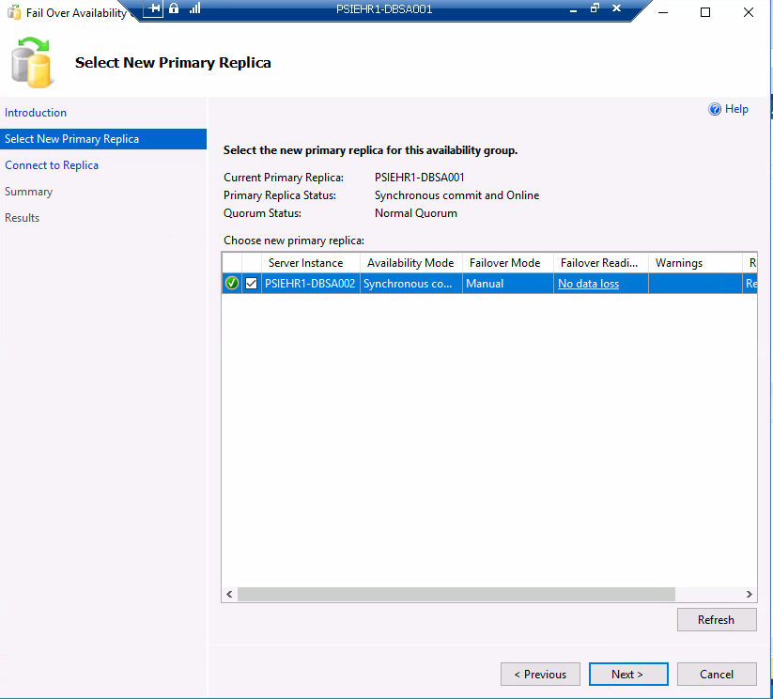
Click connect…and next…
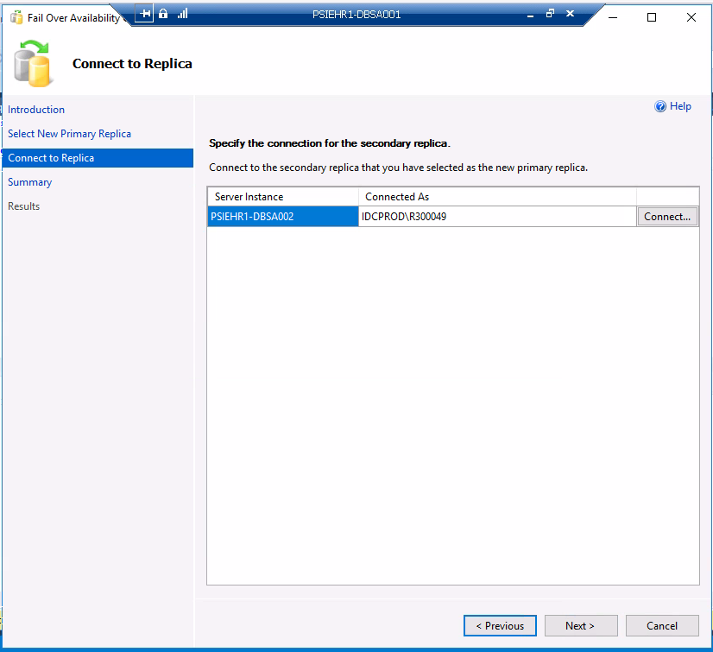

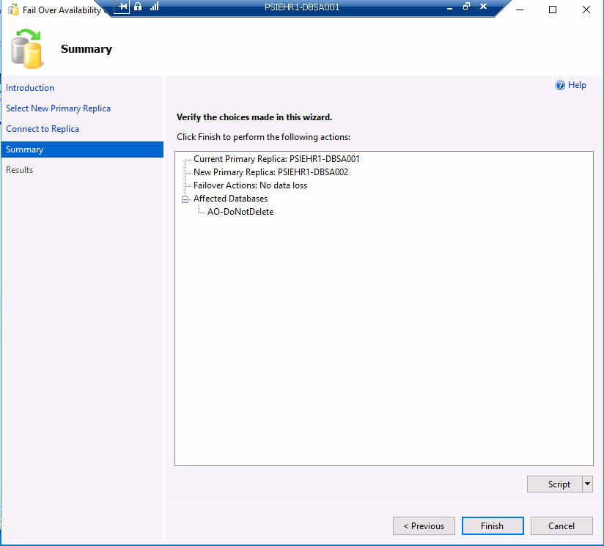

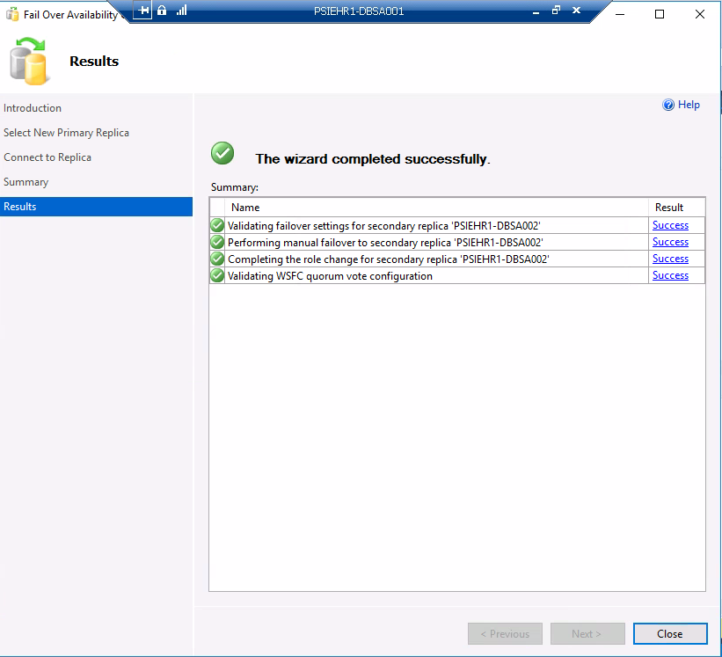

- On new Secondary: Delete the Ntier_APM_Security which has the failed upgrade changes.
- On new Primary: Add Ntier_APM_Security to the AG, use the wizard and the seeding will take about 15-30 minutes.
Choose Ntier_APM_Security and make sure it meets requisites
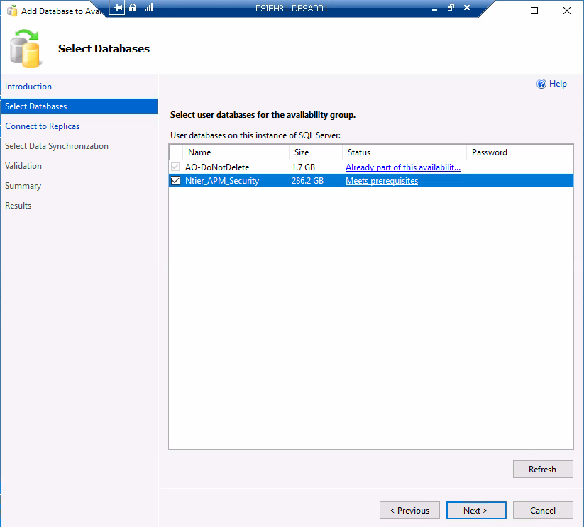

Click connect and click next..
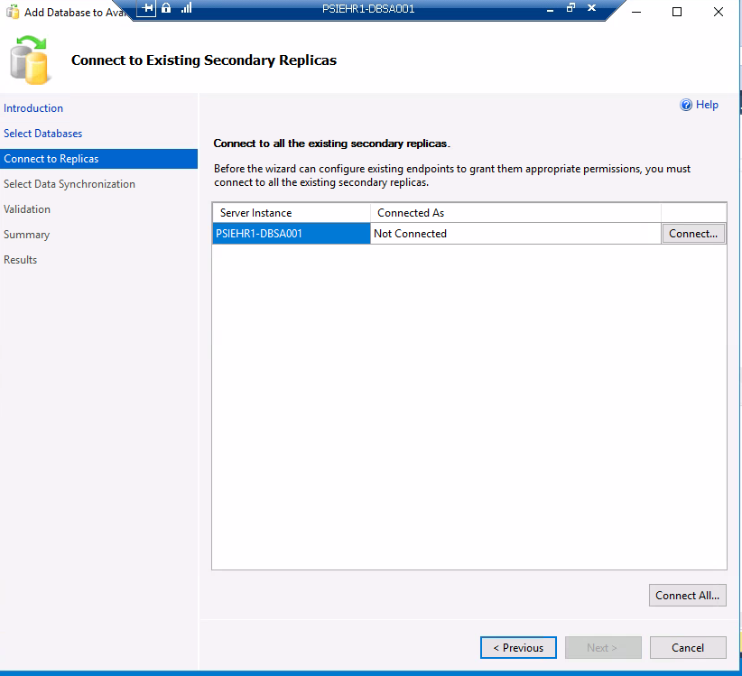

Leave the default “Automatic Seeding” and click next.
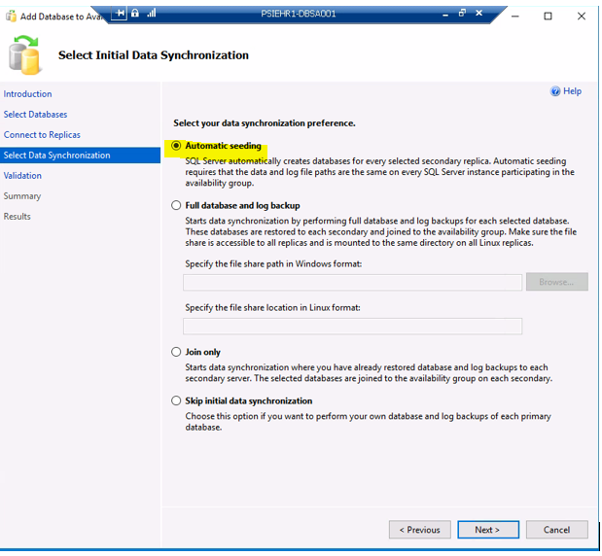

There should be enough space as we deleted the Ntier_APM_Security on the old Primary:
This is just a warning…click Next…
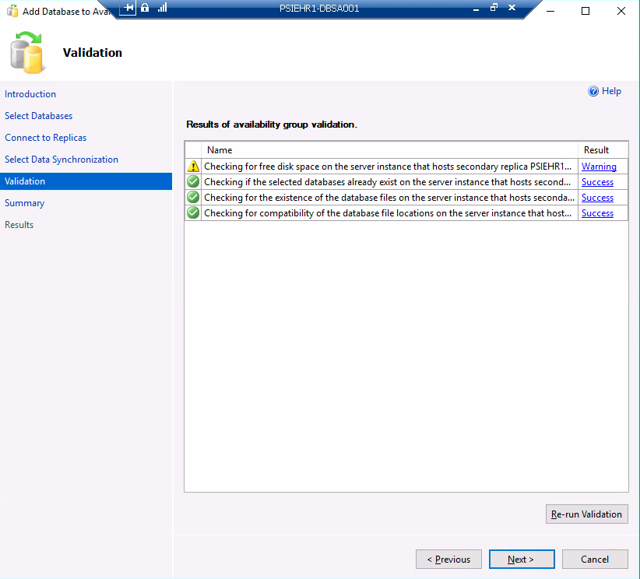

Click Finish below:
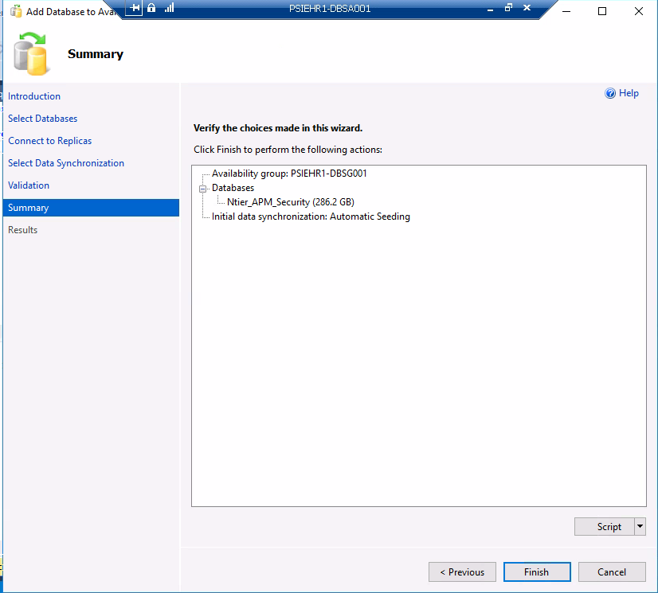

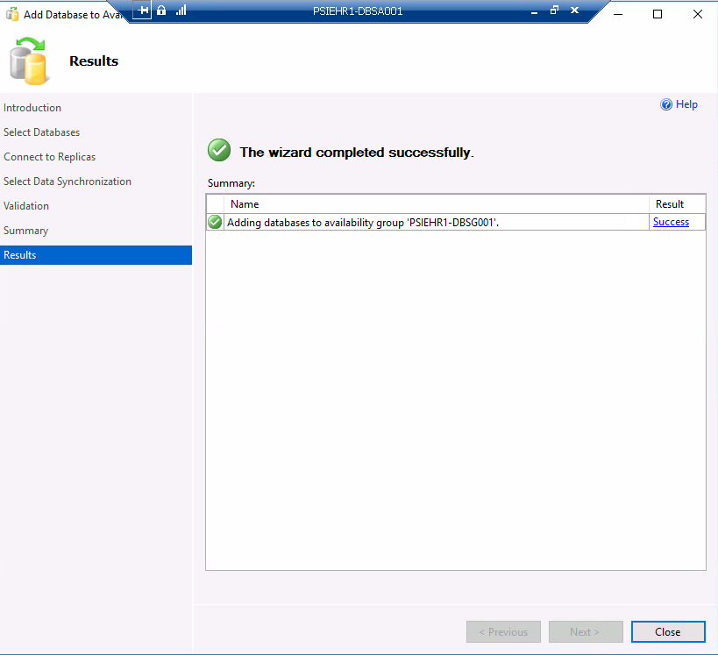
- On Secondary: Check if seeding is complete
SELECT top 1 start_time, completion_time,
ag.name,
db.database_name,
current_state,
performed_seeding,
failure_state,
failure_state_desc
FROM sys.dm_hadr_automatic_seeding autos
JOIN sys.availability_databases_cluster db
ON autos.ag_db_id = db.group_database_id
JOIN sys.availability_groups ag
ON autos.ag_id = ag.group_id
order by start_time desc
Note the Ntier_APM_Security database on the primary in a warning state (seeding..)
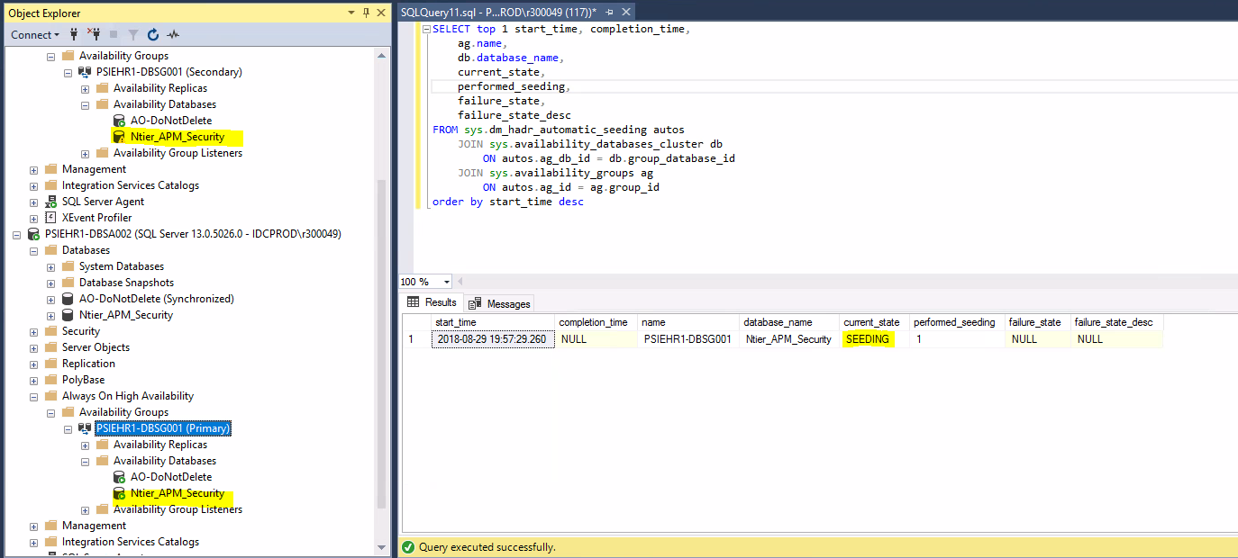
Seeding complete:
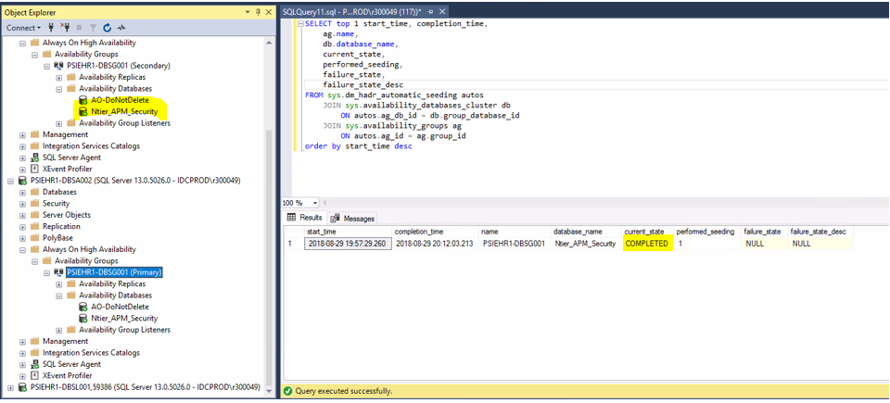
- On Primary: After the seeding is complete, change the AG failover to “Automatic”
- Now PSIEHR1-DBSA002 is Primary and PSIEHR1-DBSA001 is the Secondary, Basically the nodes swap roles in case of a failure and rollback.
All is Good! End of Upgrade process. Rollback completed. No more action needed.

BAHOT HARD

